IST 363

Lab 04

This Lab Covers
- Tailwind

Lab Corrections
- If you didn’t get a perfect score on the SASS page in lab 3, make corrections and turn in your url for this part.

warmup

  - How do utility classes in Tailwind replace writing custom CSS styles?
  - What Tailwind utility classes would you use to center a div both vertically and horizontally?
  - How can you define a custom color in Tailwind (some investigation will be needed for this question)?

SASS Page
- Tailwind Page
You will be creating a news site home page. I’ve pasted the desktop and mobile view images below. You don’t have to make this look good at tablet size unless you want to. There’s a .zip file of the processed images up in Blackboard. Match my colors by using the Tailwind reference. My blue is an indigo. The large image and footer are a version of gray.
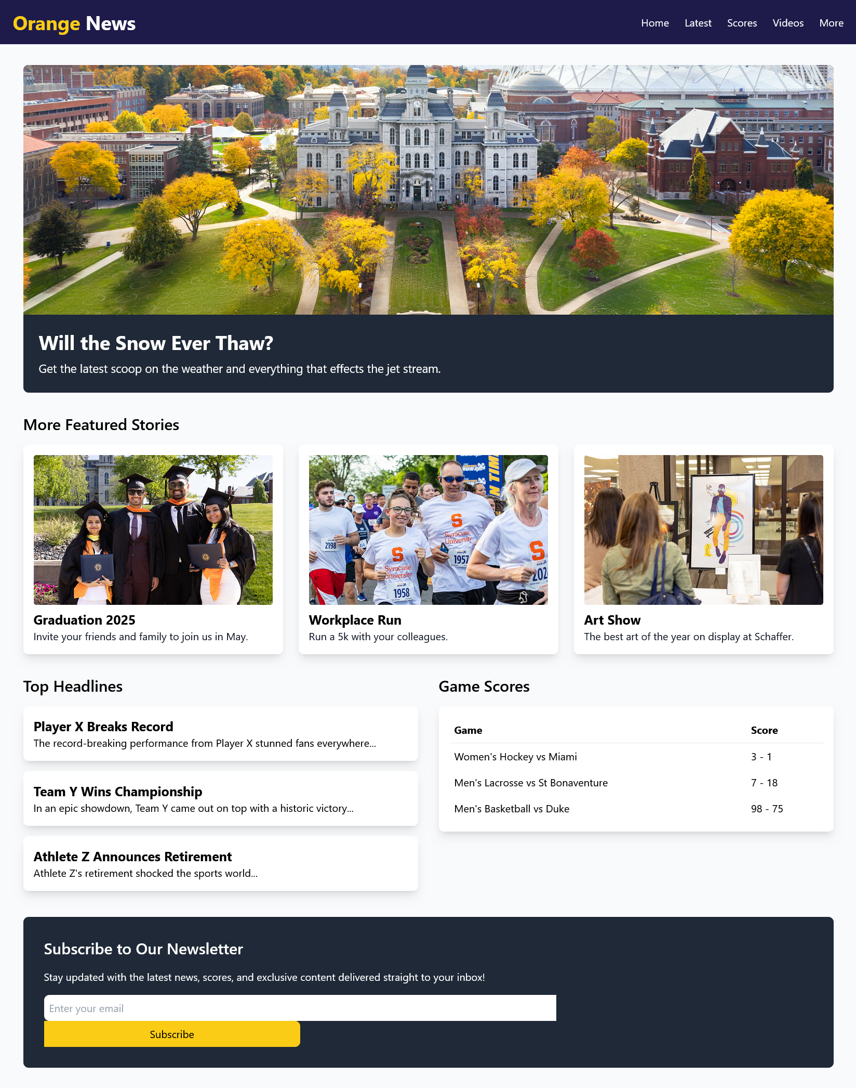 | 

What to hand in
Note that if any URL doesn’t work for me, you will get a zero on this part. Ensure github.io is part of the URL in the address bar. If it’s not, you haven’t given me the correct link.
- For the corrections hand in the URL of the corrected page.
- For the review questions, paste your answers into the template provided in Blackboard.
- For the Tailwind page, hand in the URL
Use the answer template!

